**Assignment 1:**

Create an IAM user with username of your own wish and grant

administrator policy.

**Ans:** - Steps to create the IAM user –

Login to AWS console as root -> Put IAM in search -> go to users in IAM section -> add user -> add username -> Select AWS access type -> Next -> Select Attach required policies -> Add Policy called AdministrativeAccess -> Tag a name if you want -> Create User

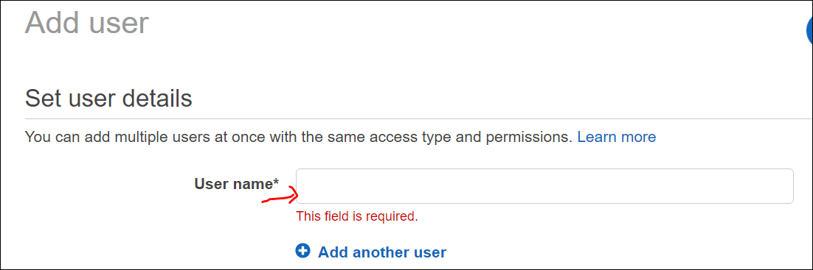

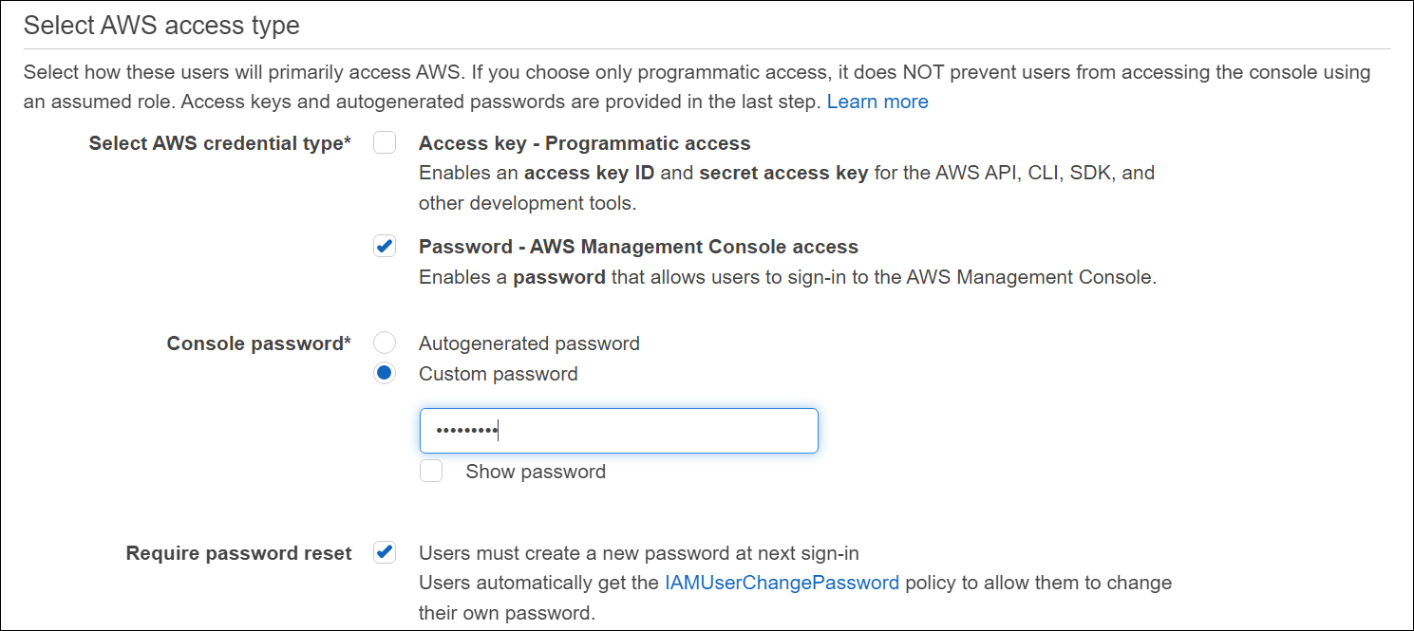

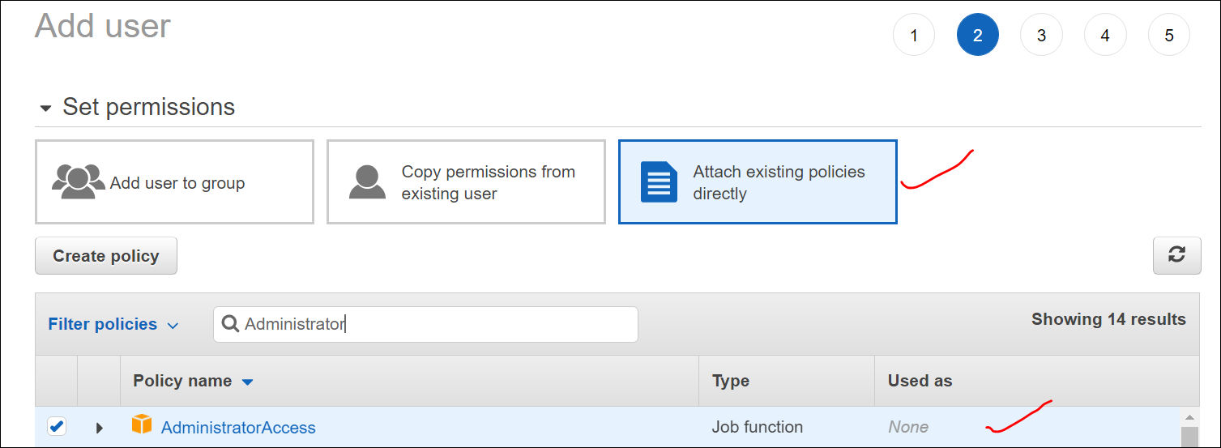

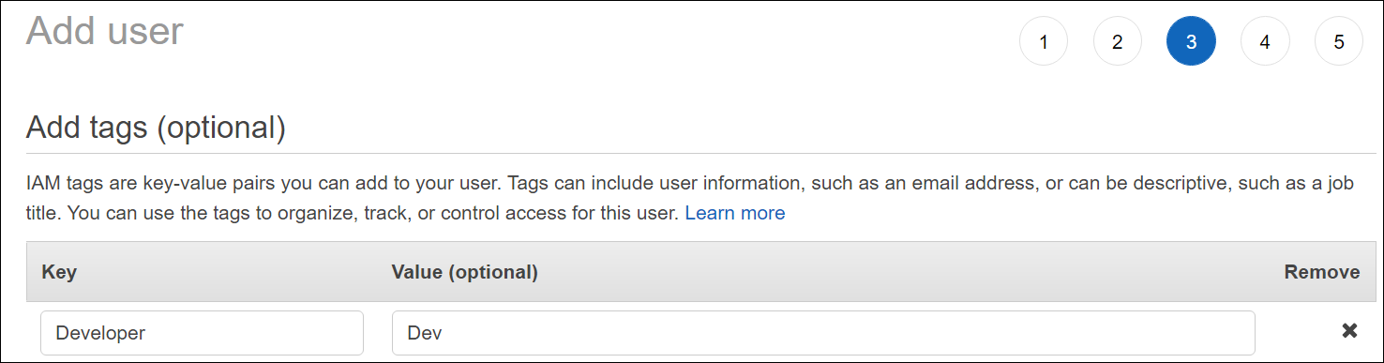

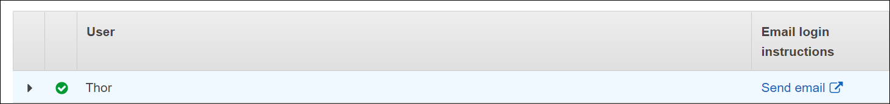

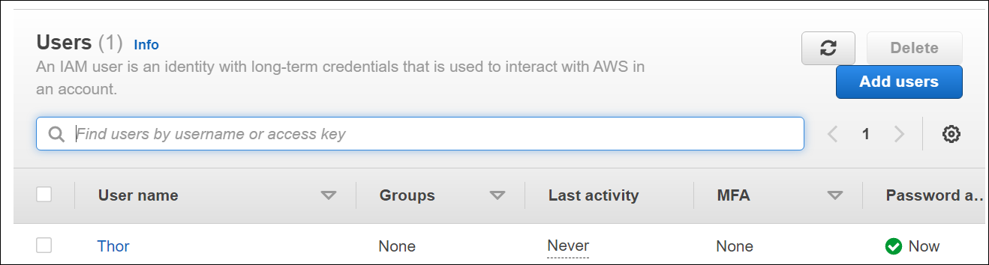

**Assignment 2: -**

Hello students, in this assignment you need to prepare a

developers’ team of avengers.

- Create 3 IAM users of avengers and assign them in developer’s groups with

IAM policy.

**Ans:** - Two more users were created.

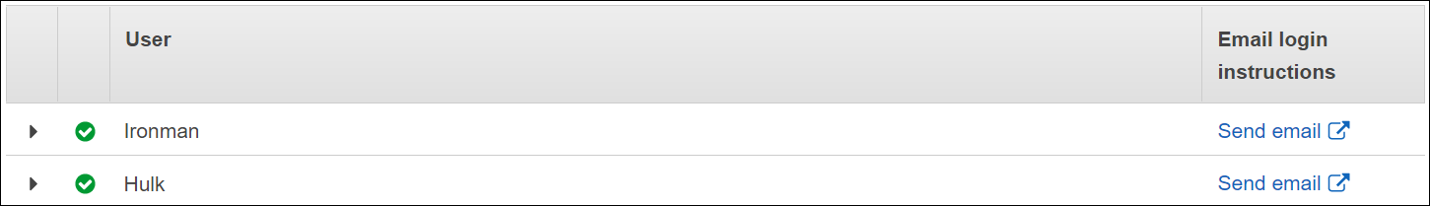

Steps to create the Group –

Go to IAM -> User groups -> in create user group add your user’s name -> Select the users want to add to the group -> Add the policy -> Create policy.

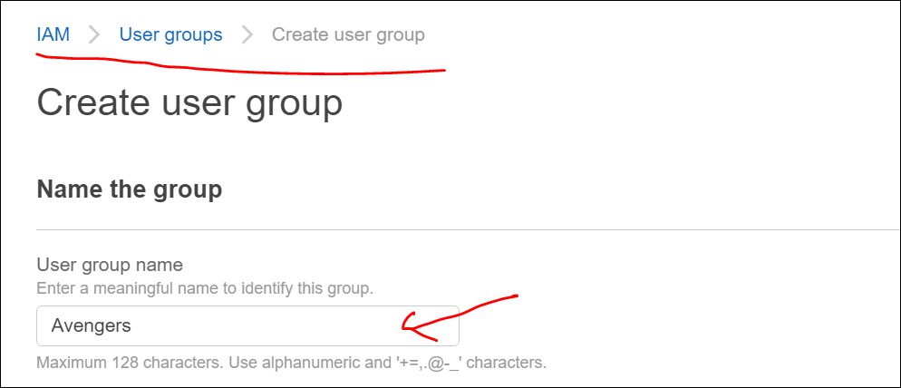

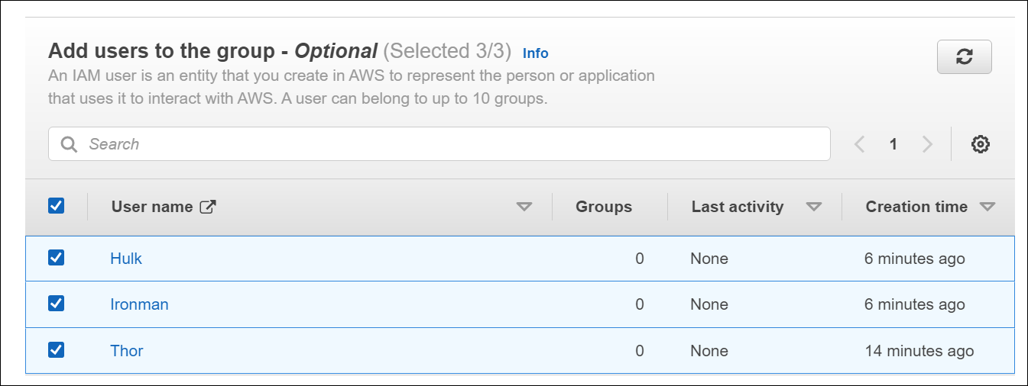 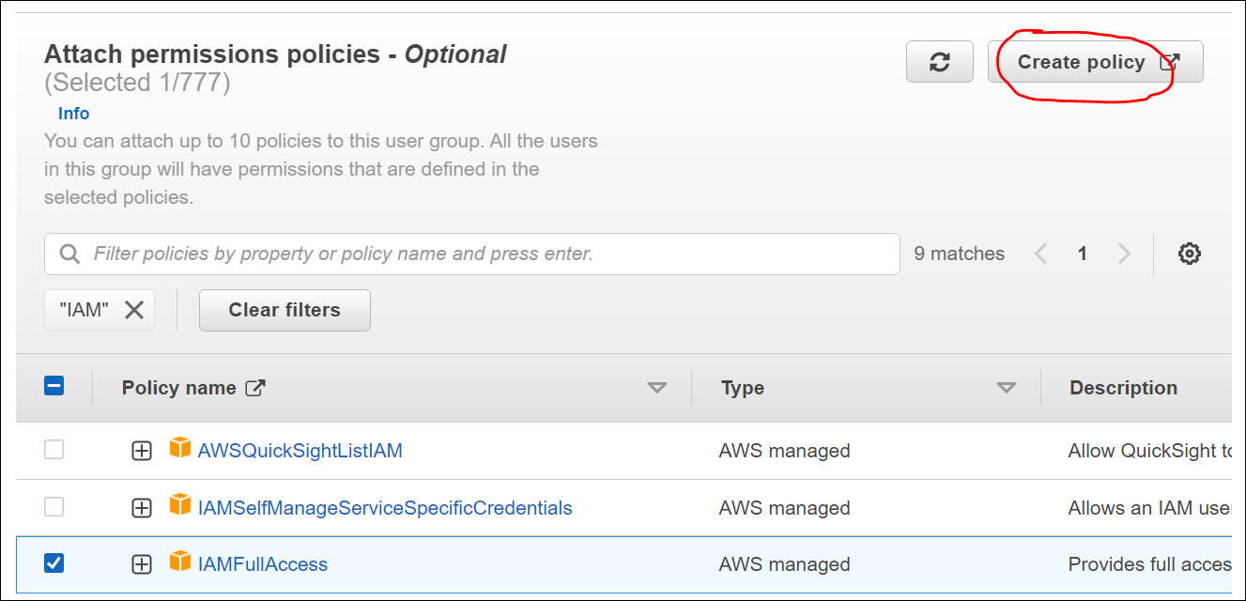

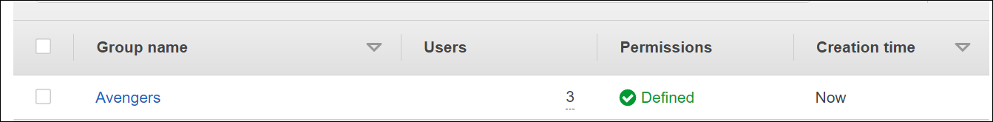

**Assignment 3: -**

**Define a condition in policy for expiration like**

"DateGreaterThan": {"aws:CurrentTime":

"2020-04-01T00:00:00Z"},

"DateLessThan": {"aws:CurrentTime":

"2020-06-30T23:59:59Z"}

**Ans:**

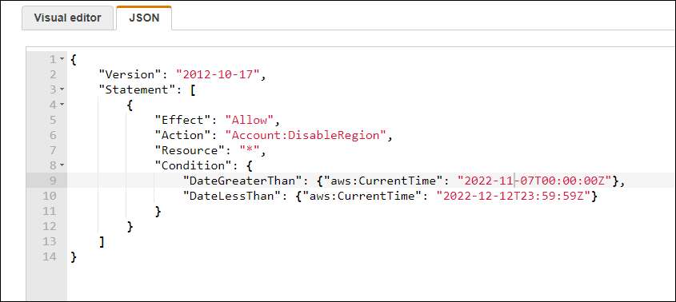

**Assignment 4: -**

1. **AWS Identity and Access Management (IAM) Service is chargeable.**
2. **TRUE**
3. **FALSE**
4. **Which of these is Identity in IAM?**
5. **Users**
6. **Groups**
7. **Roles**
8. **All of these**
9. **When you create an IAM user, you grant it permissions by making it a member of a group that has appropriate permission policies attached, or by directly attaching policies to the user.**
10. **TRUE**
11. **FALSE**
12. **You can also clone the permissions of an existing IAM user, which automatically makes the new user a member of the same groups and attaches all the same policies.**
13. **TRUE**
14. **FALSE**
15. **IAM group____________**
    1. **Is same as IAM users**
    2. **Can be used to specify permissions for a collection of use**
16. **Which of these is IAM principal?**
    1. **A user**
    2. **A role**
    3. **An application**
    4. **All of these**
17. **Temporary credentials:**
18. **It expires automatically after a specified time**
19. **Have a same set of permissions that your standard IAM user have**
20. **We can have control over the duration that the credentials are valid**
21. **A and C both**
22. **AWS evaluates _______ when an IAM principal makes a request.** 
    1. **Username and Password**
    2. **Security Policies**
    3. **IP Address**
23. **Identify the wrong statement.**
    1. **IAM can provide shared access to the AWS account**
    2. **IAM is paid service in AWS**
24. **Names of IAM identities (users, roles, and groups):**
    1. **Must be unique within the AWS account**
    2. **Must be unique within the availability zone**
    3. **Must be unique within the region**
    4. **Must be unique within the AWS cloud**
25. **An IAM user:**
    1. **is an entity that you create in AWS**
    2. **is to give people the ability to sign in to the AWS Management Console for interactive tasks and to make programmatic requests to AWS services using the API or CLI**
    3. **A and B both**
    4. **None of these**

**Assignment 5: - Launch your Linux instance in IAM and update your machine.**

**Login as IAM User – go to EC2 – create a Linux instance – Once the Instance is created – use connect option available in the dashboard – Once the VM is connected check the user info – update your machine**

**EC2 Dashboard:**

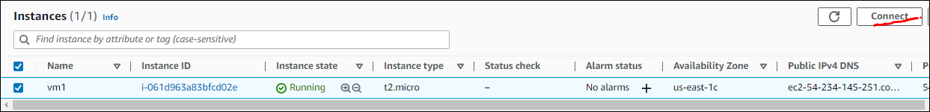

**Linux EC2 snippet:**

